UHI North, West and Hebrides (Qualifications Scotland Appeals Information for learners (exams)

The Qualifications Scotland has published its appeals process for learners on their website:
Appeals - Qualifications Scotland
Appeals 2026 is a free service that you can use if you have concerns about a Qualifications Scotland exam grade (or grades) on your results certificate. You should only appeal if you believe a mistake has been made in the external marking of your work.
If you do appeal your grade, a senior marker will carry out a marking review of your Qualifications Scotland-marked assessments. This means that they’ll review your answers to all questions and assignments marked by us. They check that the marks awarded by the original marker are in line with the marking standards agreed at the markers’ briefing and the marking instructions.
In addition, they also check that:
- all parts of your Qualifications Scotland assessments have been marked;
- the marks given for each answer have been added correctly; and
- the correct result has been entered on our system.
Please note that after being reviewed, your result could stay the same, go up or go down.
Students can make a priority appeal or a non-priority appeal.
Priority appeals can only be submitted for students who have been given a conditional offer of a place at college, university, training or employment which is dependent on their grade. Students must provide evidence of their conditional offer to the college.
UHI North, West & Hebrides, must validate your priority appeal, even if you apply directly to Qualifications Scotland. Please contact quality.nwh@uhi.ac.uk for further information.
All other appeals will be non-priority. If the college does not receive evidence of a conditional offer, the priority appeal will change to a non-priority appeal.

1. Deadlines for submitting an appeal
The service will open on Results Day, Tuesday 4 August at 9am
Learner direct submission to Qualifications Scotland deadlines are:
- Tuesday 11 August at 11:59pm for priority appeals

- Tuesday 25 August at 11:59pm for all other appeals
UHI North, West & Hebrides submission Deadlines are:
- Tuesday 18 August at 11:59pm for priority appeals

- Thursday 27 August at 5.00pm for all other appeals
2. How to submit an appeal
If candidates have requested that the college submit an appeal on their behalf, please complete the form below, with all information, and email to quality.nwh@uhi.ac.uk.

If the candidate has gone through the QS Appeals process directly, then the form below should only have the candidates name, ID, and subject confirmed, and highlight Yes when asked if the candidate has already submitted an appeal via the Direct Learner Appeals Service. This information is required only for our reference until the Appeals process is concluded.

Check the Candidate is enrolled through UHI North, West & Hebrides College. If they were enrolled with a different centre (e.g. school, another college) they need to contact that centre to process any appeal request.

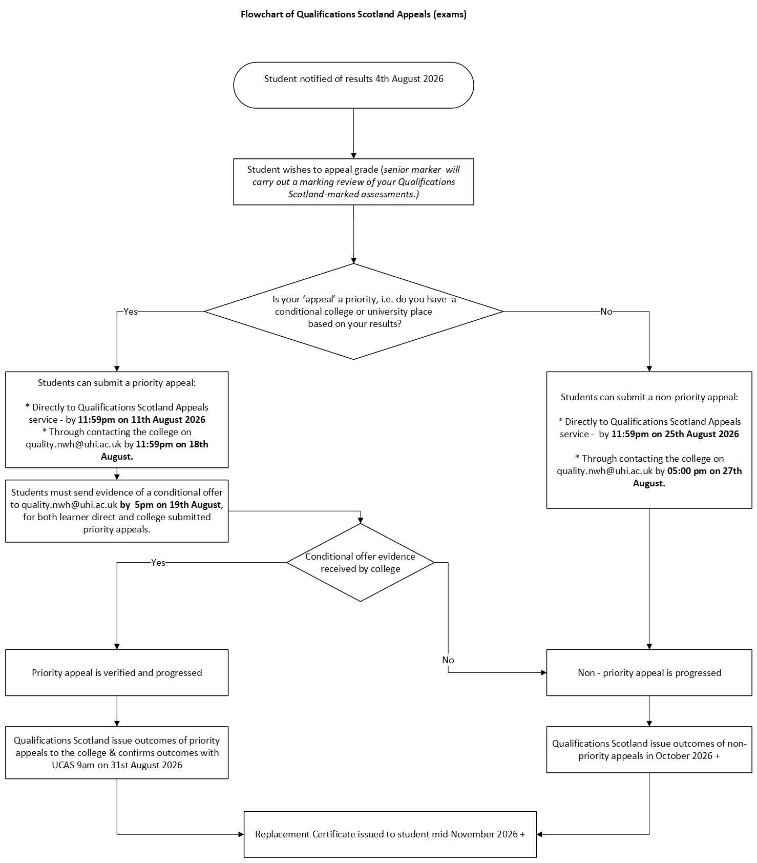

Appeals Pro-Forma
Section 1 (To be completed by member of staff submitting the request)
Candidate name
Candidate DOB:
Candidate  ID Number |  | Scottish Candidate Number (SCN)
Candidate Email Address |  | Candidate Contact Telephone:
Subject & Level |  | Exam  Grade: |  | Estimated Grade:
1. Has the candidate already submitted an appeal via the Direct Learner appeals service on the SQA Website?

If the answer is YES, no further action is required.
2. Is the students estimated grade higher than their certificated grade (e.g. the learner’s exam result is a grade C, but their estimate was a grade B?)

The answer to this must be YES to submit the appeal.
3. Does the candidate require a priority appeal?

Note: this option is only available if they have been offered a college or university place or for training/employment that is dependent on results (i.e. a conditional offer).
4. Has an advisory discussion taken place with the learner about their concerns with their certified results, ensuring that there is clarity between the learner and centre on whether the appeal is being progressed? (i.e. is the student making an informed choice?)

Note: Review page 5 of the QS Appeals Guidance 2026 to prepare for this discussion.
5. Has the student been informed that the outcomes from a marking review can result in a grade going up, staying the same or going down?

Note: It’s important to emphasise to learners that the marking review service has been designed to deal with unexpected results that indicate a possible error in marking. It is not a service to enable a review of marking for learners who are close to a grade boundary.
6. Does the student have a conditional offer from a university/college/trainer/employer? If no, continue with question
7. What is the name of College or University providing conditional offer (including Institutions contact email)?
8. What is the name of the Course/Programme for which the conditional offer has been made?
9. Has the Conditional Offer been confirmed on UCAS Portal (for degree programmes)?
10. Does the candidate wish to submit an appeal?

Note: The candidate has the final say, as long as they meet the QS criteria for submitting an appeal. Should a learner choose to not take part in an advisory conversation, or be unable to for any reason, the appeal must still be progressed if they have indicated that is their intention.
11. Has the candidate’s confirmation of appeal request been sent via email to quality.nwh@uhi.ac.uk ? Please attach.

Name of Staff Member submitting request

Section 2 (To be completed by Quality Officer): Appeal Criteria Check

1. Was an estimate grade submitted to QS for that subject and level?

Note: estimated bands of zero or blank are not eligible.

2. Did the learner take and/or submit all coursework and formal assessments, including exams?
3. Did the candidate submit an Exceptional Circumstance request?

Note: Students who submitted an EC request are not eligible for the Appeals Service.

4. Does the candidate meet the appeal criteria?

5. Has consent been received to submit appeal?
Name of Quality Officer

